Supplementary Information for
Biocompatibility Profile of a Unique Dual-Biomaterial Hydrogel-Based Medical Device for Intraarticular Use in Osteoarthritis
Burcu Gur *, Kris Van den Cruys, Jorg Schelfhout
Pre-Clinical Department, Allegro NV/SA, Liege, Belgium

Supplementary Information - Methods

S2.3.1. In Vitro Cytotoxicity
Extraction was performed in single-strength Eagle Minimum Essential Medium (EMEM10) at 37 ± 1°C for 72 ± 2 hours (0.2 g/mL). Extracts were diluted to 50%, 25%, and 12.5% (v/v). Positive control extracts were prepared at 25%, 20%, 15%, 10%, and 3% (v/v). Triplicate L-929 monolayers were incubated at 37 ± 1°C, 5 ± 1% CO₂ for 24–26 hours. MTS-PMS reagent (20 µL/well) was added and incubated for 120–135 minutes before absorbance reading at 492 nm.

S2.3.2. In Vitro Genotoxicity
Bacterial Reverse Mutation Assay (Ames Test)
In vitro genotoxicity of the test article, Hydrogel OA 2%, was assessed using a bacterial reverse mutation assay (Ames test). The test article was evaluated for its potential to induce reverse mutations at the histidine locus of Salmonella typhimurium tester strains TA98, TA100, TA1535, and TA1537, and at the tryptophan locus of Escherichia coli strain WP2uvrA.
Hydrogel OA 2% was extracted in 0.9% sodium chloride (NaCl) and dimethyl sulfoxide (DMSO). The assay was conducted in both the presence and absence of metabolic activation (rat liver S9 mix). Tubes containing molten top agar were inoculated with bacterial culture and the test article extracts at 100 μL/plate of 100%, 75%, 50%, 25%, 12.5%, and 6.25% (v/v). Phosphate buffer or S9 mixture was added as appropriate, and the mixture was poured onto triplicate plates. Parallel testing included control blanks and appropriate positive controls. The mean number of revertant colonies was compared with the corresponding vehicle control for each tester strain.
Table S1. Specifications of Control Blank and Extraction Vehicle Solvents.
Attribute | Sodium Chloride (SC) | Dimethyl Sulfoxide (DMSO)
Solvent Type | Polar | Polar (organic solvent)
Supplier | Aguettant | Sigma-Aldrich
Reference Number | 600502 | D1435
CAS Number | 7647-14-5 | 67-68-5
Compliance | Meets European Pharmacopeia requirements | Meets European Pharmacopeia and United States Pharmacopeia requirements
Table S2. Positive Control Reference Standards and Their Specifications.
Name | Reference | Composition or Other Characteristics
2-nitrofluorene | Sigma-Aldrich, reference N16754 | CAS No. 607-57-8
9-aminoacridine | Sigma-Aldrich, reference A38401 | CAS No. 52417-22-8
Methyl methanesulfonate | Sigma-Aldrich, reference 129925 | CAS No. 66-27-3
Sodium azide | Sigma-Aldrich, reference S8032 | CAS No. 26628-22-8
2-aminoanthracene | Sigma-Aldrich, reference A38800 | CAS No. 613-13-8
Benzo [a] pyrene | Sigma-Aldrich, reference B1760 | CAS No. 50-32-8
Table S3. Positive Control Conditions by Tester Strain.
Positive Control | Concentration | S9 | Tester Strain
Benzo [a] pyrene 2-nitrofluorene | 2.5 μg/plate 2.5 μg/plate | Presence Absence | TA98
2-aminoanthracene Sodium Azide | 2.0 μg/plate 2.0 μg/plate | Presence Absence | TA100
2-aminoanthracene Sodium Azide | 2.0 μg/plate 0.5 μg/plate | Presence Absence | TA1535
2-aminoanthracene 9-Aminoacridine | 2.5 μg/plate 70.0 μg/plate | Presence Absence | TA1537
2-aminoanthracene Methyl methanesulfonate | 16.0 μg/plate 325.0 μg/plate | Presence Absence | WP2uvrA
Table S4. Extraction Parameters for Test Article by Vehicle.
Vehicle | Extraction Ratio | Article Amount | Volume of Vehicle | Extraction Conditions
SC | 0.2 g/mL | 3.7359 cm2 | 18.7 mL | 37%C ± 1°C for 72 hours ± 2 hours
DMSO | 0.2 g/mL | 3.7162 cm2 | 18.6 mL | 37%C ± 1°C for 72 hours ± 2 hours
In Vitro Micronucleus Assay
Genotoxicity was further evaluated using an in vitro micronucleus assay to detect chromosome damage or mitotic spindle disruption. The test item was prepared in ethanol at a maximum initial concentration of 500 mg/mL and applied at 1% in culture medium, resulting in a final concentration of 5000 μg/mL. Human lymphocyte cultures were exposed to Hydrogel OA 2% with and without metabolic activation (S9 fraction). Following treatment, cells were cultured in RPMI 1640 medium for a period sufficient to allow one mitotic division. Harvested and stained interphase cells were examined microscopically for micronuclei in binucleated cells.

Table S5. pH and Osmolality of Test and Control Preparations.
Compound | Final concentrations (µg/mL) | pH | Osmolality (mOsmol/kg) | Osmolality variation (mOsmol/kg) Compared to solvent control
Culture medium (RPMI) | 0 | 7.74 | 275
Solvent Control (culture medium + 10% ethanol) | 0 | 7.81 | 440
Hydrogel OA 2% | 5000 | 7.84 | 399 | -41
Hydrogel OA 2% | 2500 | 7.83 | 421 | -19
Hydrogel OA 2% | 1250 | 7.85 | 437 | -3
HPRT Gene Mutation Assay in Mouse Lymphoma Cells (OECD 476)
Hydrogel OA 2% was evaluated for induction of forward mutations at the hypoxanthine-guanine phosphoribosyl transferase (HPRT) locus using L5178Y Tk+/− -3.7.2C mouse lymphoma cells. The assay was conducted according to OECD Test Guideline 476 (2016). Treatments were performed in the presence and absence of metabolic activation using S9 mix derived from phenobarbital- and β-naphthoflavone-induced rat liver.
Sodium chloride (0.9%) was used as the vehicle. Negative controls included DMSO and untreated controls (R0P). A preliminary cytotoxicity test was conducted to determine appropriate test concentrations achieving 10–90% relative survival (RS). Cells were exposed to various concentrations of the test item, followed by cloning in 96-well microtiter plates to determine cloning efficiency (CE) and resistance to 6-thioguanine (6-TG). Positive controls included 4-nitroquinoline-1-oxide (4NQO) without metabolic activation and 7, 12-dimethylbenzanthracene (DMBA) with metabolic activation. Colonies were scored after 7–12 days, and mutation frequency was calculated. Statistical analysis of mutation frequency data was performed using GraphPad Prism® version 10.4.1.
The test item was finally diluted for treatment by adding 400 μL to 40 mL of appropriate tissue culture medium containing 2 × 107 cells.
Table S6. Nominal Concentrations of Test Suspensions for Mutation Assay.
Dose | Nominal concentration mg/mL (concentration in the test system (μg/mL))
1 | 15.63 (156.3)
2 | 31.25 (312.5)
3 | 62.50 (625.0)
4 | 125.0 (1250)
5 | 250.0 (2500)
6 | 500.0 (5000)
Table S7. Positive Controls.
Positive control chemical | Genotoxic action | Solvent | Test (final) concentration μg/mL | Metabolic activation (±S9)
7, 12 Dimethyl benzanthracene (DMBA) | Mutagen (+S9 only) | DMSO | 1 | +
4-nitroquinoline-1-oxide (4NQO) | Mutagen | DMSO | 0.2 | -
Thymidine Kinase (TK) Mutation Assay in Human TK6 Cells (OECD 490)
To assess mutagenic potential in human cells, a thymidine kinase (TK) gene mutation assay was conducted using the human lymphoblastoid TK6 cell line in accordance with OECD Test Guideline 490 (2016). The test article was dissolved in ethanol at 500 mg/mL, and serial dilutions were prepared. Preliminary cytotoxicity testing was performed to determine appropriate concentrations.
Cells were exposed under short-term (4 h) and long-term (24 h) conditions, both in the presence and absence of metabolic activation using S9 mix (Aroclor 1254-induced rat liver). Following treatment, cells underwent a three-day phenotypic expression period. Cloning efficiency was assessed in non-selective medium, and mutant frequency was determined in trifluorothymidine (TFT)-selective medium. Positive controls included methyl methanesulfonate (MMS) without S9 and cyclophosphamide (CPA) with S9. Plates were incubated for 10–14 days, and mutation frequencies were calculated from the number of non-growing wells. Statistical analysis was performed using one-sided Dunnett’s test.
Table S8. pH and Osmolality of Hydrogel OA Test Preparations and Controls.
Compound | Final concentrations (µg/mL) | pH | Osmolality (mOsmol/kg) | Osmolality variation (mOsmol/kg) Compared to solvent control
Culture medium (RPMI) | 0 | 7.64 | 274 | -
Solvent Control (culture medium + 1% ethanol) | 0 | 7.70 | 430 | -
Hydrogel OA 2% | 5000 | 7.83 | 414 | -16
Hydrogel OA 2% | 2500 | 7.82 | 444 | +14
Hydrogel OA 2% | 1250 | 7.79 | 461 | +31
Hydrogel OA 2% | 625 | 7.72 | 454 | +24

S2.3.3. Guinea Pig Maximization Test
Ten guinea pigs received intradermal induction (Induction I) and topical induction (Induction II). Five control animals received 0.9% NaCl. Challenge patches were applied after recovery. Reactions were scored at 24 ± 2 and 48 ± 2 hours.

S2.3.4. Rabbit Pyrogen Study – Detailed Protocol
Animals were screened using a pyrogen-free solution. Rabbits with baseline temperatures outside 38.2–39.6°C or variation >0.2°C were excluded. Three rabbits with baseline differences ≤1°C were selected. Extract (10 mL/kg, 38 ± 1°C) was injected into the marginal ear vein. Temperatures were recorded every 30 minutes for 3 hours.

S2.3.5. Intracutaneous Study Details
0.2 mL injections were administered at five sites per article in three rabbits. Observations were performed at 24, 48, and 72 hours and daily until Day 14.

S2.3.6. Acute Systemic Toxicity – Detailed Monitoring
Animals were weighed prior to dosing and allocated if within ±20% mean weight. Observations occurred at 4 ± 0.4, 24 ± 2, 48 ± 2, and 72 ± 2 hours. Body weights were recorded at 24, 48, and 72 hours.

S2.3.7. Rat Systemic Toxicity – Study Design
Group sizes were 24 (4 weeks), 40 (13 weeks), and 60 (26 weeks), equally distributed by sex. Weighing and examinations occurred weekly (4- and 13-week studies) and biweekly after week 13 (26-week study). Organs were weighed and examined macroscopically and microscopically.

S2.3.8. Intra-Articular Study – Detailed Design
Forty-seven rabbits (including reserves) received bilateral injections (~400 µL per knee). Analgesia was administered prior to anesthesia. Animals were balanced across timepoints. Negative controls included fewer sites due to established safety of saline. Synovial fluid smears were stained with May-Grünwald Giemsa. Histological stains included SHE, ABS, and SOFG. Findings were graded on a five-point scale per ISO 10993-6.

S2.3.9. Chemical Characterization – Detailed Extraction
Exhaustive extraction was performed by non-volatile residue (NVR) methodology. Water extracts (37°C) were additionally analyzed by ICP-MS. AET in µg/mL was calculated considering extraction ratios and DBT derived from TTC thresholds per ISO/TS 21726.

Supplementary Information – Results

S3.2. In Vitro Genotoxicity
Ames Test
No ≥2-fold increase in revertants for TA98, TA100, or WP2uvrA and no ≥3-fold increase for TA1535 or TA1537 were observed in the presence or absence of S9. NaCl and DMSO extracts of Hydrogel OA 2% were therefore classified as non-mutagenic in Salmonella typhimurium (TA98, TA100, TA1535, TA1537) and Escherichia coli WP2uvrA.
In Vitro Micronucleus Assay
Short-term treatment (±S9) followed by 24-hour recovery produced no statistically significant increases in micronucleated binucleated cells at any tested concentration. The Cochran-Armitage trend test was not significant. At the highest concentration, values were within historical solvent control ranges. Similar findings were observed in continuous treatment (−S9).
HPRT Assay (OECD 476, 2016)
Negative controls (0.9% NaCl, DMSO, untreated) were within 95% confidence limits of historical control ranges for L5178Y cells. Positive controls produced significant MF increases (RS ≥10%), confirming assay sensitivity.
Cytotoxicity assessment showed:
- −S9 exposure up to 5000 µg/mL: mean RS = 106%
- +S9 exposure at 5000 µg/mL: mean RS = 77% (mild cytotoxicity)
No precipitation was observed; visible particulates occurred ≥2500 µg/mL due to the suspended formulation.
No statistically significant or biologically relevant increases in MF were detected under −S9 or +S9 conditions. ANOVA showed no concentration-related trend. All MF values remained within 95% confidence limits of historical controls, except one +S9 concentration (2500 µg/mL) which was below the lower limit but within the broader historical distribution and deemed non-impactful. No procedural deviations occurred.
Hydrogel OA 2% was therefore classified as non-mutagenic at the HPRT locus.
TK Gene Mutation Assay (OECD 490, 2016)
Three treatment conditions were evaluated:
- 4-hour exposure −S9
- 4-hour exposure +S9
- 24-hour exposure −S9
Maximum concentration: 5000 µg/mL (OECD limit dose).
Relative survival (RS):
- 4-hour −S9: 120.7%
- 4-hour +S9: 122.2%
- 24-hour −S9: 79.2%
Solvent controls were within historical control ranges. Positive controls (MMS without S9; CPA with S9) produced significant MF increases, confirming assay validity.
Across all concentrations and conditions, Hydrogel OA 2% did not induce statistically or biologically significant increases in total MF (small or large colonies). All values remained below the global evaluation factor (126 × 10⁻⁶ mutants) and within historical control distributions.

S3.7. 4-13-26 Week Systemic Toxicity in Rat
Table S9. Sampled Tissue List for the Animals included in the Systemic Toxicity Study.
Organ System | Tissues
Circulatory | Heart
Digestive | Liver
Endocrine | Adrenals
Excretory | Kidneys
Integumentary | Skin
Lymphatic | Spleen, Thymus, Lymph nodes (axillary and mesenteric)
Muscular | Muscle
Nervous | Brain
Reproductive | Testes/Ovaries
Respiratory | Lungs, Bronchi
Skeletal | Sternum
Haematopoietic | Sternum (Bone marrow)

S3.8. Local Tissue Effects Study in Rabbit
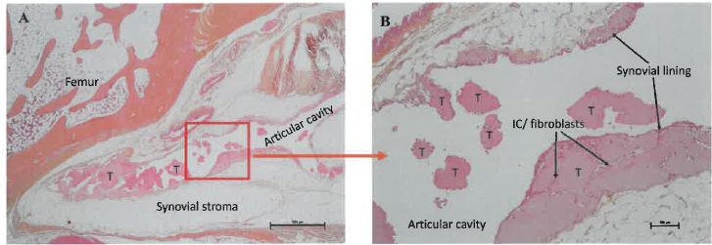
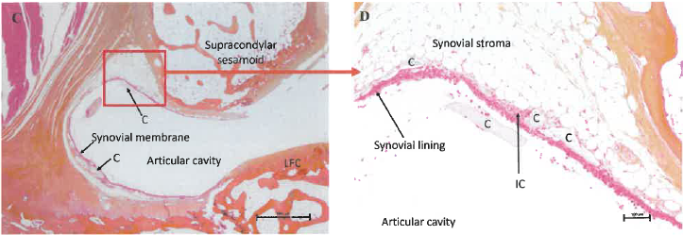
Figure S1. Representative Photomicrographs of Intra-articular Space at Week 1.
IC: Inflammatory cells, LFC: Lateral Femoral Condyle
T: Test article
C: Control
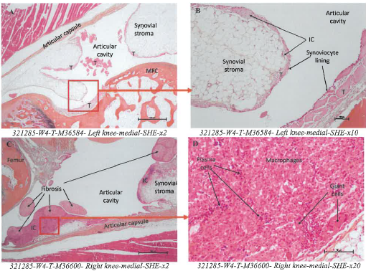
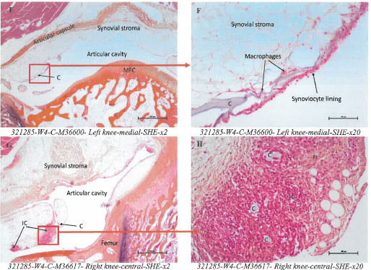
IC: Inflammatory cells; Fi: Fibrosis; MFC: Medial Femoral Condyle
Figure S2. Representative Photomicrographs of Intra-articular Space at Week 4.
(A-B): Low-grade local tissue reaction in a test article joint: the test article in the synovial stroma is infiltrated by scant inflammatory cells.
(C-D): High-grade local tissue reaction in a test article joint: the synovial stroma is focally replaced by fibrosis, a heavy infiltrate of macrophages -with fewer giant cells and a moderate lympho-plasmacytic infiltrate. The reaction is higher than the one observed in the contralateral joint injected with the control article (see E-Ffor comparison).
(E-H): Local tissue reaction in control article joints. The local tissue reaction in control article joints ranged from minimal (E-F) to slight (G-H).
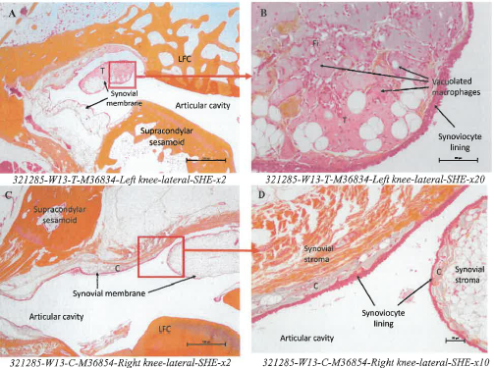
Fi: Fibrosis; LFC: Lateral Femoral Condyle
Figure S3. Representative Photomicrographs of Intra-articular Space at Week 13.
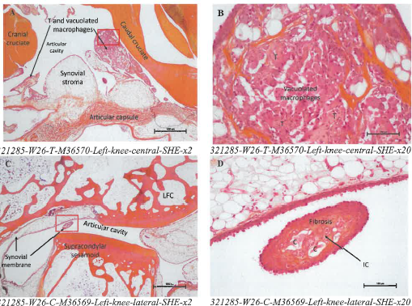
IC: Inflammatory cells, LFC: Lateral Femoral Condyle
Figure S4. Representative Photomicrographs of Intraarticular Space at Week 26.

S3.9. Chemical Characterization/TRA
Table S10. Summary of the toxicological evaluation for compounds not handled by TSL.
Compound Name | Grouped / Groups | CAS No. | Mw (g/mol) | Confidence | Quantity Extracted (µg/device) | EEDmax Adult (µg/kg/d) | TI (systemic toxicity) (µg/kg/d) | MoS
NON-GROUPED EXTRACTABLES
Acetaldehyde | - | 75-07-0 | 44 | Confident | 1.1 | 0.0183 | 1.5 | 82
Acetone | - | 67-64-1 | 58 | Confident | 63 | 1.0500 | 450 | 429
Isopropyl Alcohol | - | 67-63-0 | 60.1 | Confident | 1500 | 25.0 | 1000 | 40
Cyclic poly (ethylene acid) (n=01) poly (trimethylene carbonate) (n=02) copolymer | - | 113883-69-5 | 262.068 | Tentative | 38 | 0.6333 | 750 | 1184
ELEMENTS
Chromium (Cr) | - | - | - | Confident | 0.17 | 0.0028 | 0.1 | 35.7
Tungsten (W) | - | - | - | Confident | 0.34 | 0.0057 | 4.7 | 824

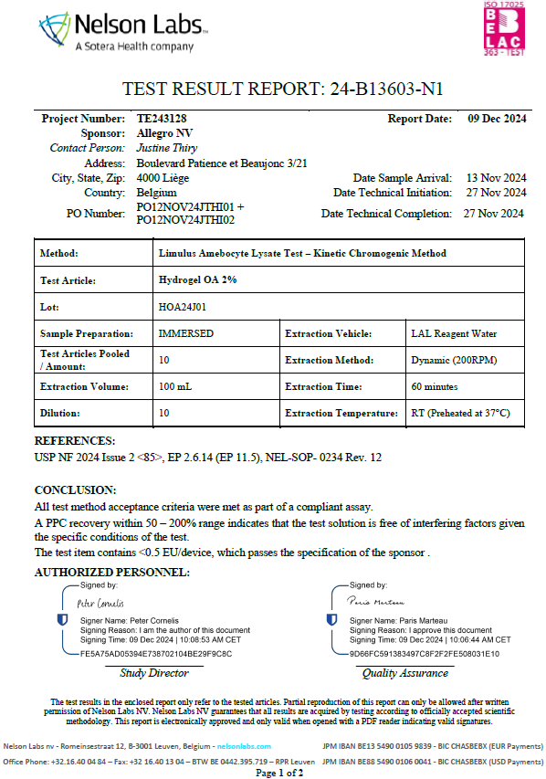
Figure S5. Page 1 of Bacterial Endotoxin Testing Report Demonstrating Compliance with Endotoxin Limits for Hydrogel OA 2%.
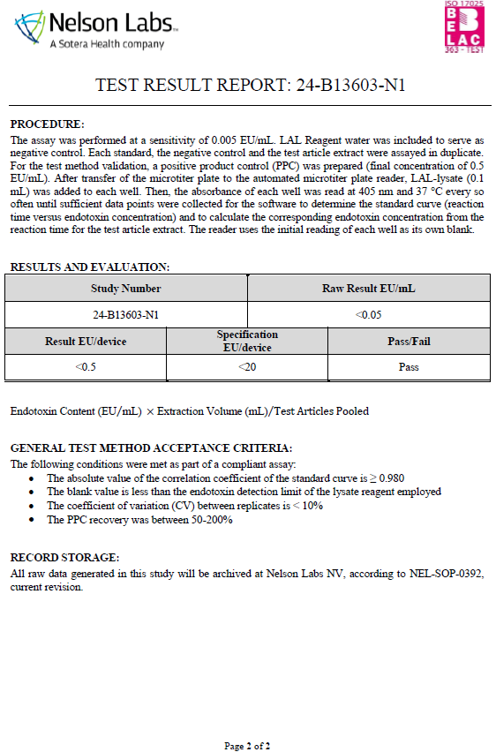
Figure S6. Page 2 of Bacterial Endotoxin Testing Report Demonstrating Compliance with Endotoxin Limits for Hydrogel OA 2%.

