Criterion | Inclusion Criteria | Exclusion Criteria
Population | • Adult surgical patients (≥18 years of age) undergoing surgery requiring regional anesthesia for intraoperative or postoperative analgesia. | • Pediatric patients (<18 years) unless data for adults were reported separately.  • Animal studies or cadaveric studies
Intervention | • Fascial plane blocks  • Perineural adjuncts (dexamethasone).  • Ultrasound guidance  • Continuous catheter technique (programmed intermittent bolus).  • Liposomal bupivacaine | • Traditional nerve blocks without any “new” element  • Neuraxial techniques (spinal, epidural) unless they incorporated a novel adjunct or ultrasound guidance as the main intervention  • Non-regional techniques
Comparator | • Traditional nerve blocks • Landmark technique  • Perineural alternative adjunct (dexmedetomidine) • Different infusion regimen (continuous infusion).
Outcomes | • Duration of analgesia, cumulative opioid consumption • first‑pass success rate  • local anesthesia consumption • procedure time

Supplementary table 1. Inclusion and exclusion criteria with PICO

PRISMA 2020 Flow-char
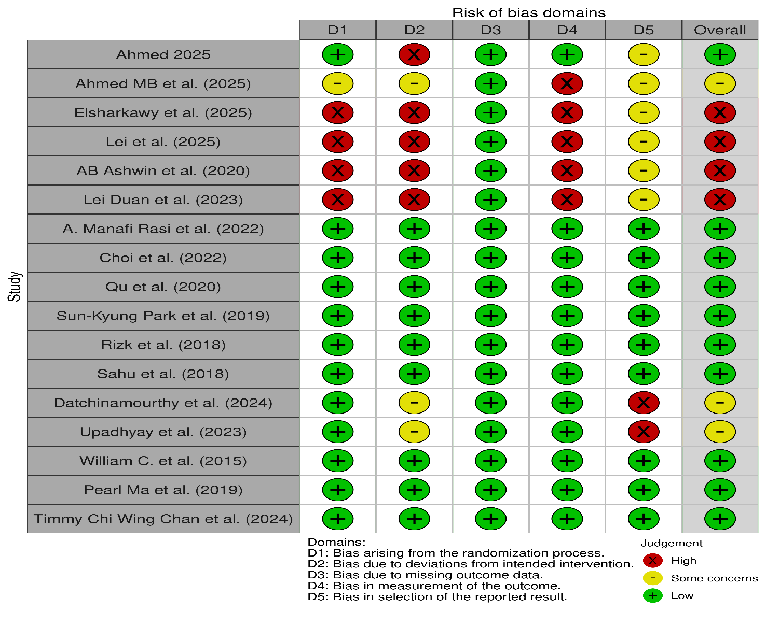
Supplementary fig. 1 risk of bias assessment
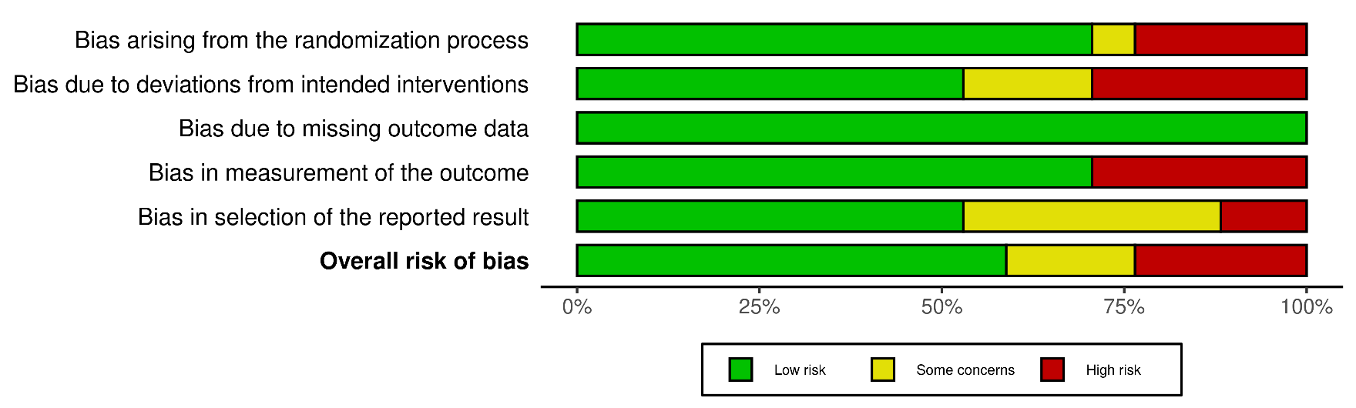
Supplementary fig.2 summary of risk of bias

Supplementary table 2. Characteristics of articles included in this systematic review and meta-analysis
Study | Sample Size (I/C) | Surgery Type | Geographic Location | Comparison | Primary Outcome(s)
Ahmed MB et al. 2025 | 24 / 24 | Unspecified | Unspecified | Fascial  Plane vs.  Traditional  Nerve Blocks | Postoperative  analgesia &  opioid consumption
Elsharkawy et al. 2025 | 35 / 35 | Cesarean section | Egypt | Fascial  Plane vs.  Traditional  Nerve Blocks | Postoperative  analgesia &  opioid consumption
Lei et al. 2025 | 30 / 30 | Unspecified | Unspecified | Fascial  Plane vs.  Traditional  Nerve Blocks | Postoperative  analgesia &  opioid consumption
AB Ashwin et al. 2020 | 40 / 30 | Unspecified | Unspecified | Fascial  Plane vs.  Traditional  Nerve Blocks | Postoperative  analgesia &  opioid consumption
Lei Duan et al. 2023 | 22 / 22 | Unspecified (likely cardiac) | Unspecified | Fascial  Plane vs.  Traditional  Nerve Blocks | Postoperative  analgesia &  opioid consumption
A. Manafi Rasi et al. 2022 | 30 / 22 | Hip fracture | Iran | Fascial  Plane vs.  Traditional  Nerve Blocks | Postoperative  analgesia &  opioid consumption
Choi et al. 2022 | 27 / 41 | Unspecified (likely cardiac/thoracic) | Unspecified | Fascial  Plane vs.  Traditional  Nerve Blocks | Postoperative  analgesia &  opioid consumption
Qu et al. 2020 | 40 / 40 | Hip fracture (elderly) | China | Ultrasound vs. Landmark | First-pass success rate  & operation time
Sun-Kyung Park et al. 2019 | 40 / 40 | Unspecified (elderly) | South Korea | Ultrasound vs. Landmark | First-pass success rate  & operation time
Rizk et al. 2018 | 120 / 60 | Unspecified (elderly) | Lebanon | Ultrasound vs. Landmark | First-pass success rate  & operation time
Sahu et al. 2018 | 38 / 38 | Unspecified | India | Ultrasound vs. Landmark | First-pass success rate  & operation time
Datchinamourthy et al. 2024 | 25 / 25 | Modified radical mastectomy | India | PIB vs.  Continuous  Infusion | Local  anesthetic  consumption
Upadhyay et al. 2023 | 16 / 15 | Upper limb surgery | Unspecified | PIB vs.  Continuous  Infusion | Local  anesthetic  consumption
William C. et al. 2015 | 8 / 6 | Unspecified | Unspecified | Liposomal vs. Standard Bupivacaine | Postoperative  analgesia
Pearl Ma et al. 2019 | 9 / 8 | Shoulder surgery | Unspecified | Liposomal vs. Standard Bupivacaine | Postoperative  analgesia
Timmy Chi Wing Chan et al. 2024 | 40 / 40 | Upper limb surgery | China | Liposomal vs. Standard Bupivacaine | Postoperative  analgesia

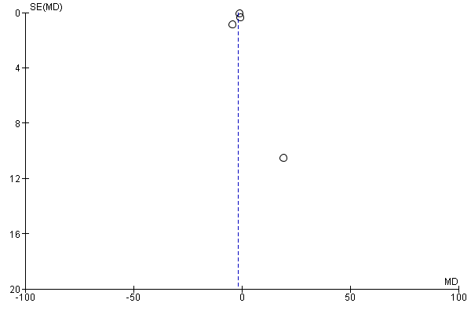
Supplementary fig.3 funnel Plot of Fascial Plane Blocks vs. Traditional Nerve Blocks for Postoperative analgesia

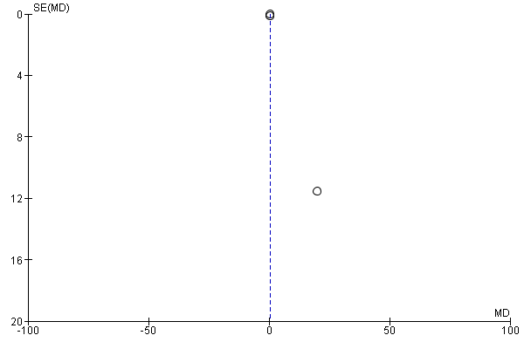
Supplementary fig.4 funnel plot of ultrasound Guidance vs. Landmark for Neuraxial/Blocks Interms of First‑pass success (3 RCTs)

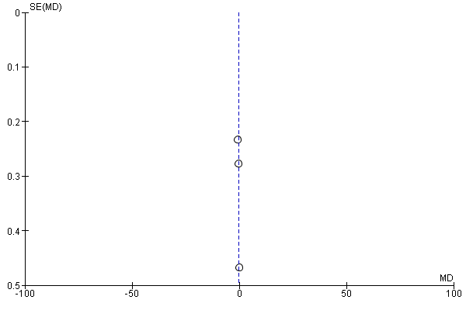
Supplementary fig.5 liposomal bupivacaine vs. standard bupivacaine for postoperative analgesia (3 RCTs)

