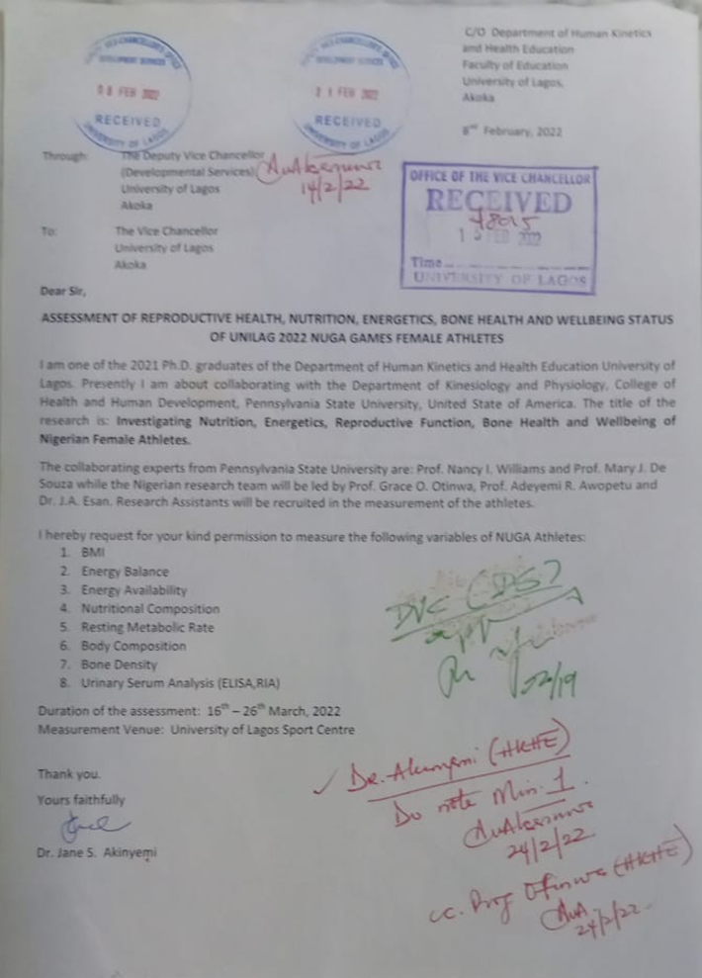
Social approval was secured in 3 weeks. This permission was necessary to carry out the tests at the University of Lagos environment. The approval letter was signed by the Vice Chancellor, Deputy Vice Chancellor, Head of Department, Human Kinetics and Health Education and Head of Unit, Exercise Physiology. On this basis, we contacted the coaches, sport directors and medical personnel.
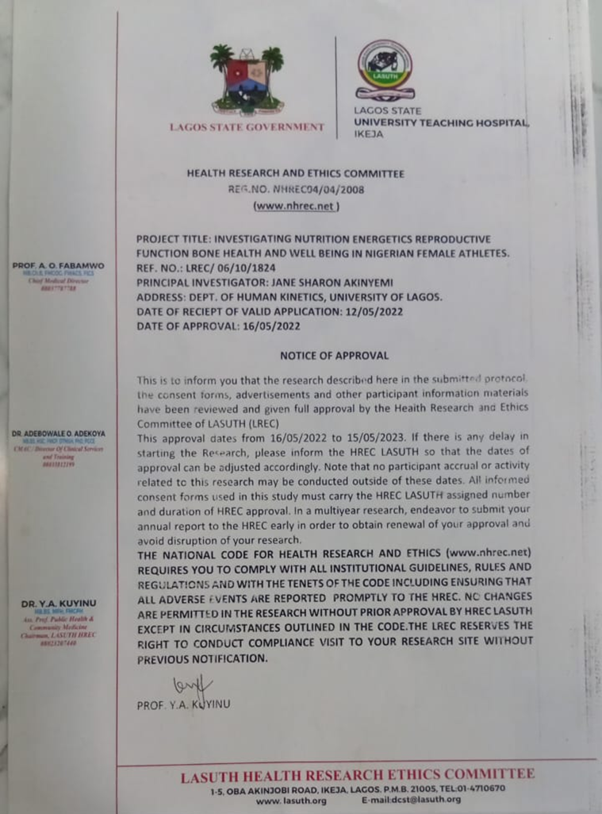
Ethical documents for approval were processed within one month. It was obtained from the Health Research and Ethics Committee with registration number NHREC04/04/2008 from the Lagos State University Teaching Hospital.

ALL IMAGES ARE PRESENTED HERE BASED ON PERMISSION FROM PARTICIPANTS TO DISPLAY THE PICTURES
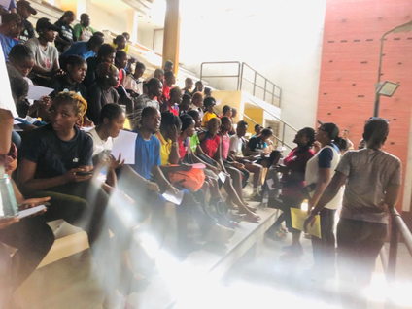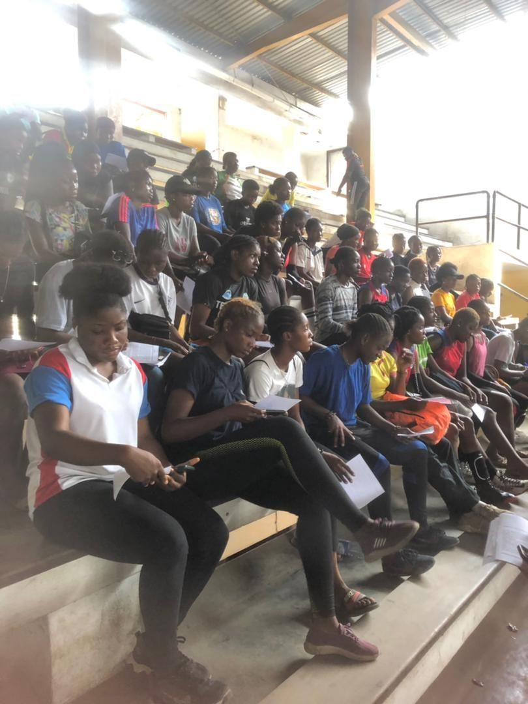
The investigators, meeting with female athletes at the University of Lagos Sports Center to discuss the aims and demands of the study to seek consent for their willing participation
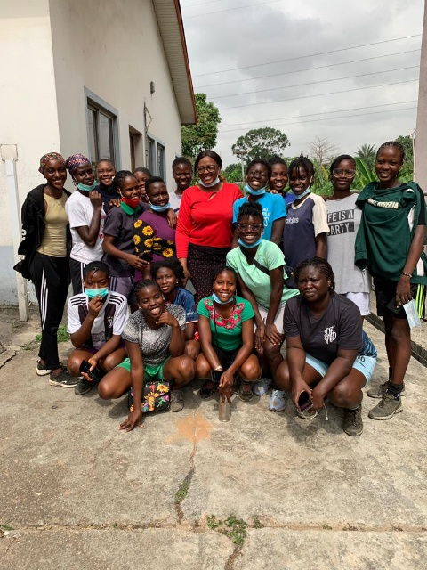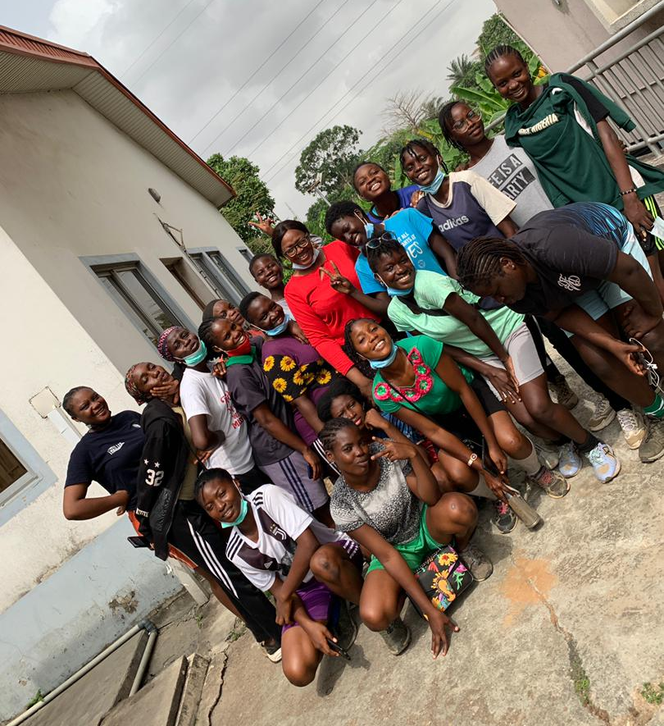
Some research participants with the lead researchers pose for group photographs
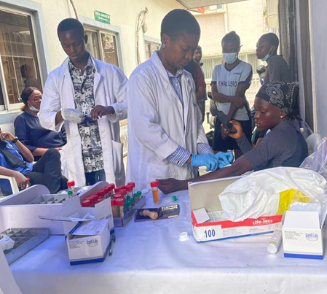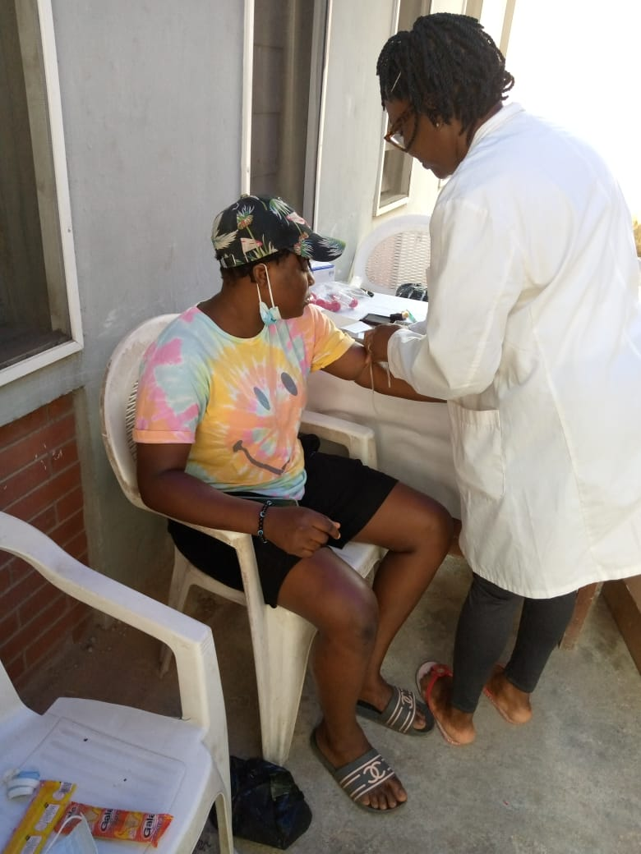
Blood draw for hematological assessment at the University of Lagos Health Center
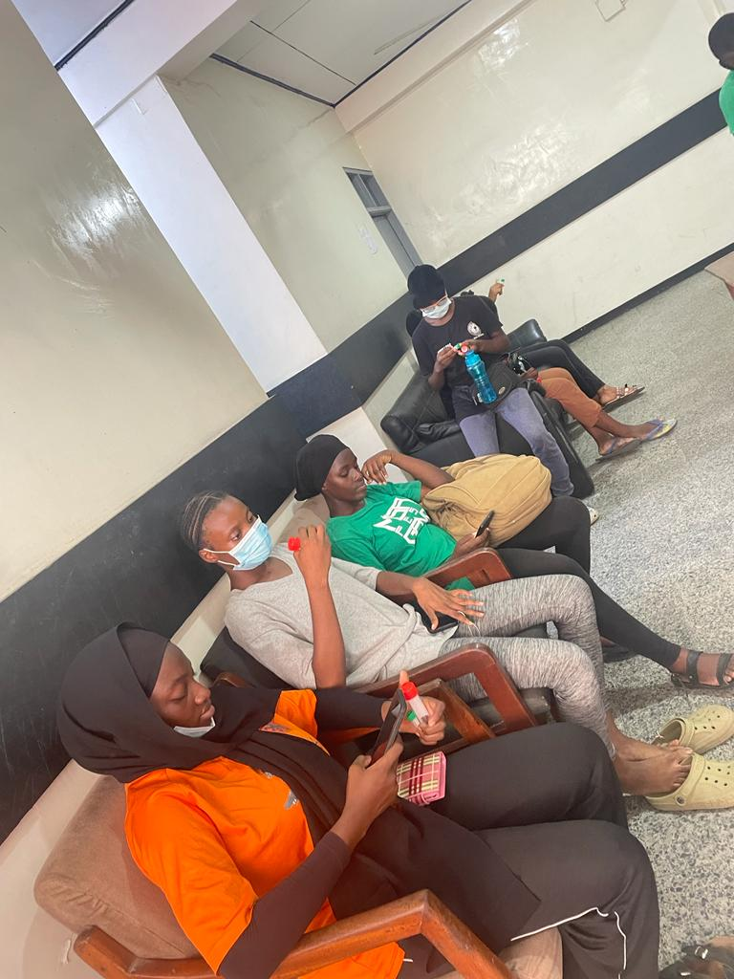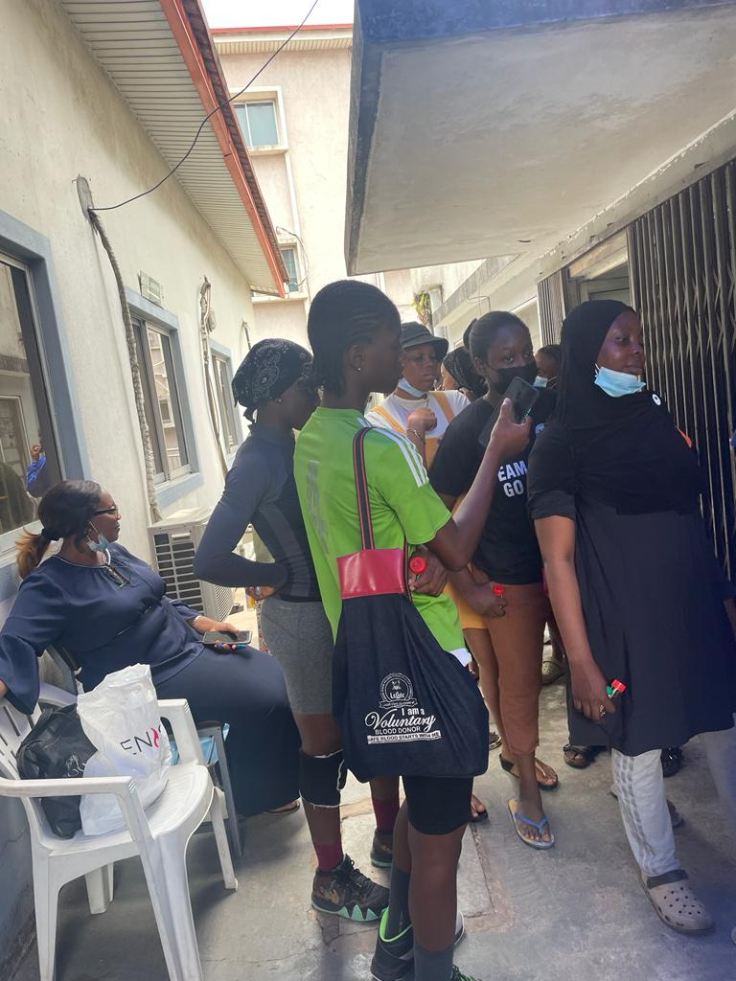
Female athletes’ participants waiting to take turns for blood draw
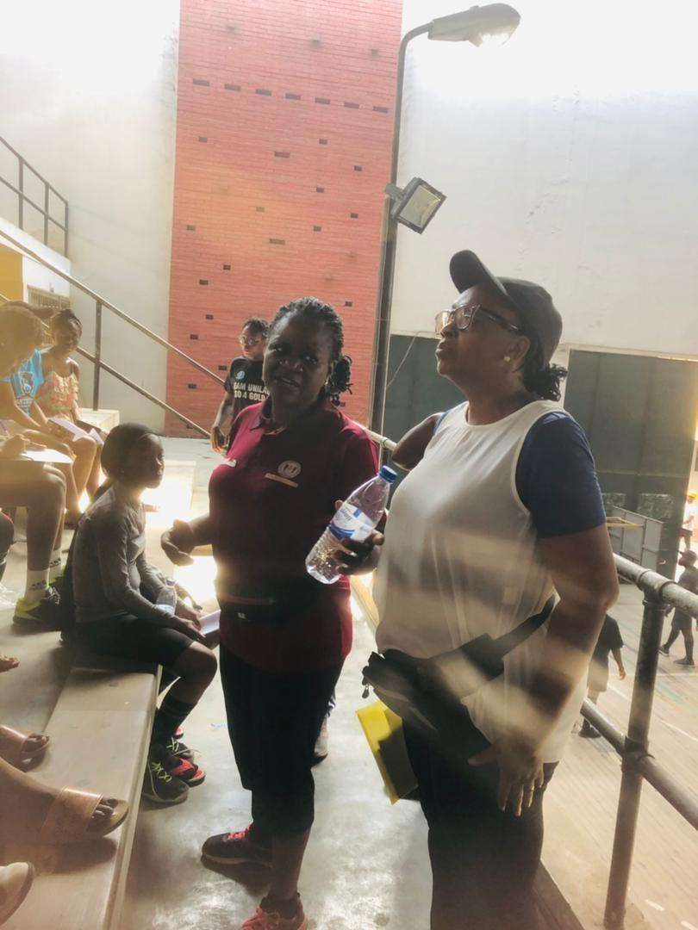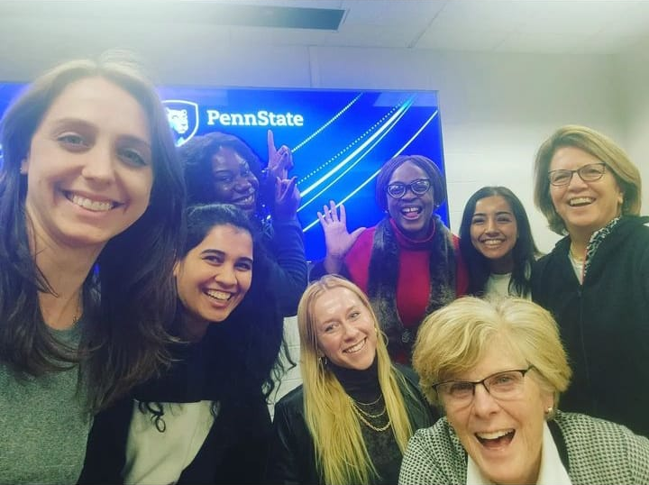
Investigators: (a) University of Lagos and (b) the Women’s Health and Exercise Laboratory Pennsylvania State University

