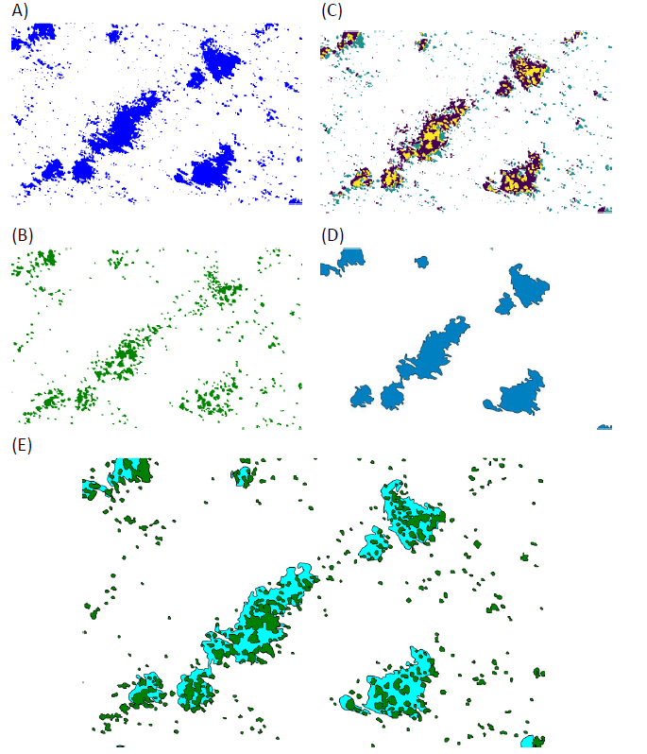
Figure S1. Steps leading to automatic mapping of ponds (excerpt).
(A) Discrimination of ponds by processing the NIRGB image from September 2018 (rainy season) - classes 1 to 3 of the unsupervised classification; (B) Tree vegetation with increasing density near and within ponds; (C) Result of aggregating layers A and B so that the pond footprints include the vegetation covering or adjacent to them; (D) Mapping of ponds after removal of objects smaller than 500 m2 and generalization of shapes; (E) Ponds and tree vegetation, extract from the situation in 2016 in the study area.
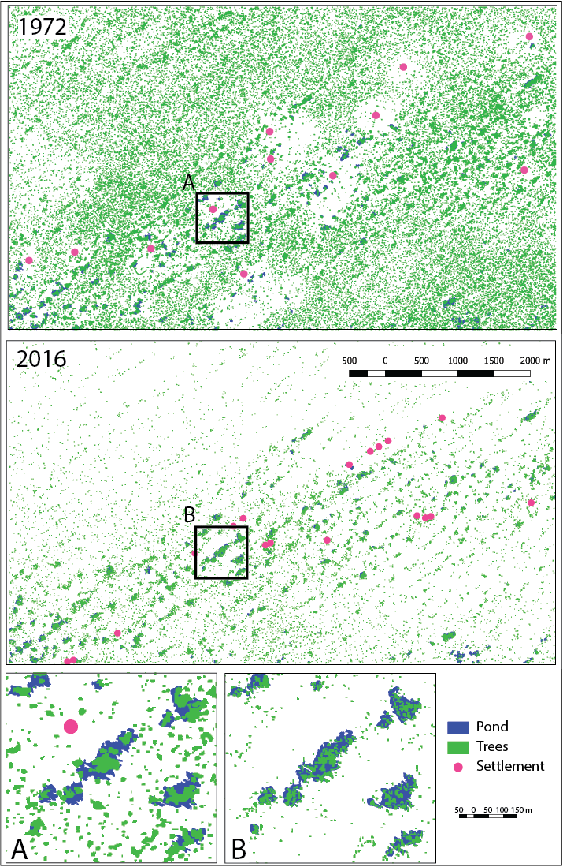
Figure S2. Distribution of tree vegetation in the study area in 1972 and 2016.

